Read the clues and then complete the puzzle.

C:\Users\Rich\Documents\eslkidsworld.com\clip art\Money\Cartoons (J - N)\Money - Sad.wmfC:\Users\Rich\Documents\eslkidsworld.com\clip art\Money\Coins & Currency\Coins - Gold 1.wmf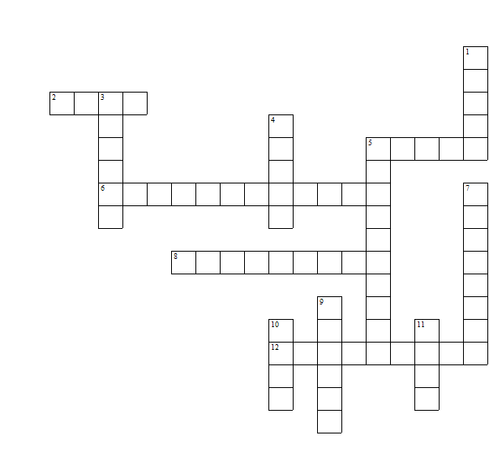

It’s ___________________

They are ______________

***Down:***

1 Paper used as money ___________

3 A list of all planned expenses and revenues ___________

4 An object that is generally accepted as payment for goods and services ___________

5 A card which you can buy things on credit ___________

7 Fees paid on borrowed assets ___________

9 A piece of paper (usually) that orders a payment of money ___________

10 The redistribution of financial assets, between the lender and the borrower ___________

11 A financial intermediary that accepts deposits ___________

***Across:***

2 When you owe money ___________

5 A piece of metal that is used for trade ___________

6 The rate of exchange between currencies ___________

8 A place where you withdraw money ___________

12 When withdrawals from a bank account exceed the available balance ___________

***Teacher’s answers***

