Name: ____________________

G for _oat

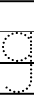
11
2

G for _irrafe
G for _arlic

