Name: ___________________

J for _aguar

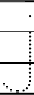
11
2
J for _ellyfish

J for _eans

