Name: ___________________

M for _onkey

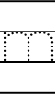
21
3
11

M for _ouse

M for _irror

