Name: ___________________

O for _ctopus

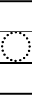
11

O for _tter

O for _ven

