Name: ___________________

P for _anda

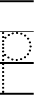
11
2

P for _uma

P for _each

