Name: ___________________

U for _nicorn

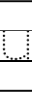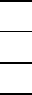
11
2

U for _mbrella

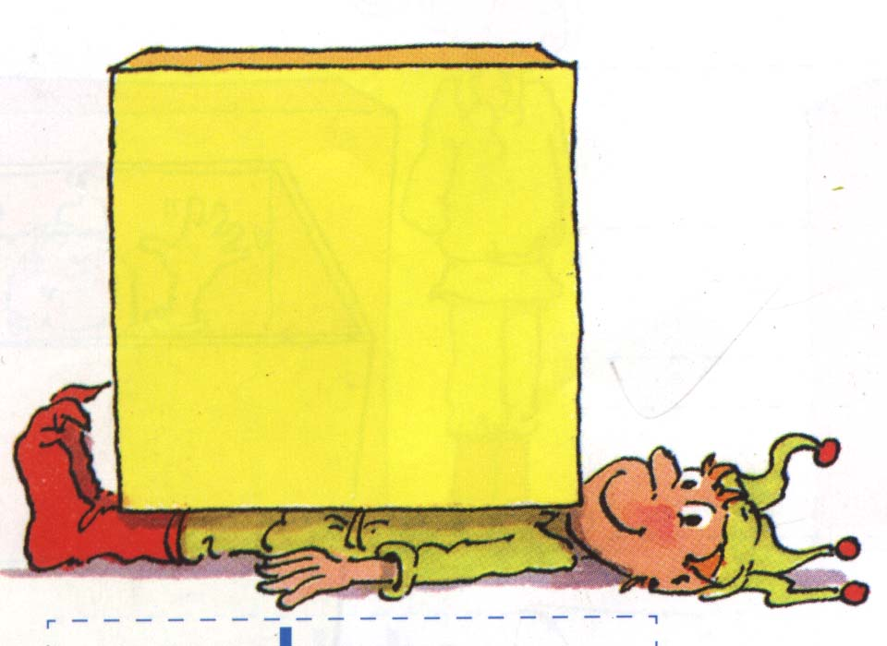

U for _nder

