Name: ___________________

W for _olf

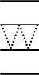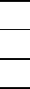
W for _hale
11
41
31
21

W for _indow

