Name: ____________________

A for _nt

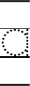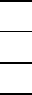
11
2
A for _lligtor

A for _pple

