Name: ____________________

B for _ear

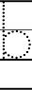
11
2

B for _at

B for _anana

