Name: ____________________ D for _og

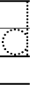
D for _onkey D for _oll
11
2

