Name: ___________________

E for _agle

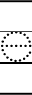
11
2

E for _lephant
E for _gg

