Name: ___________________

F for _rog

11

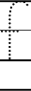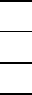
2
F for _ox
F for _an

