Name: ____________________

H for _orse

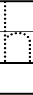
11
2

H for _ippo

H for _at

