Name: ___________________

K for _oala

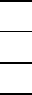
11
21
31

K for _angaroo

K for _iwi

