Name: ___________________

N for _ine

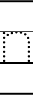
11
2
1

N for _ewt

N for _otebook

