Name: ___________________

Q for _uestion

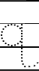
11
2

Q for _uail

Q for _uilt

