Name: ___________________

R for _abbit

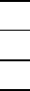
11
2

R for _hino

R for _ing

