Name: ___________________

S for _nake

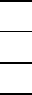
11

S for _hark
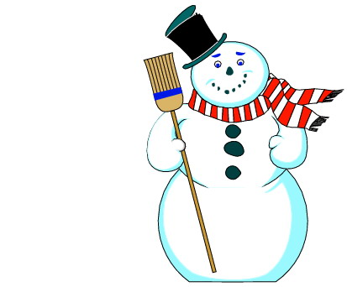

S for _nowman

