Name: ___________________

Z for _ero

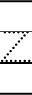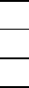
11
21
31
Z for _ebra

Z for _ip

